**wget command:**

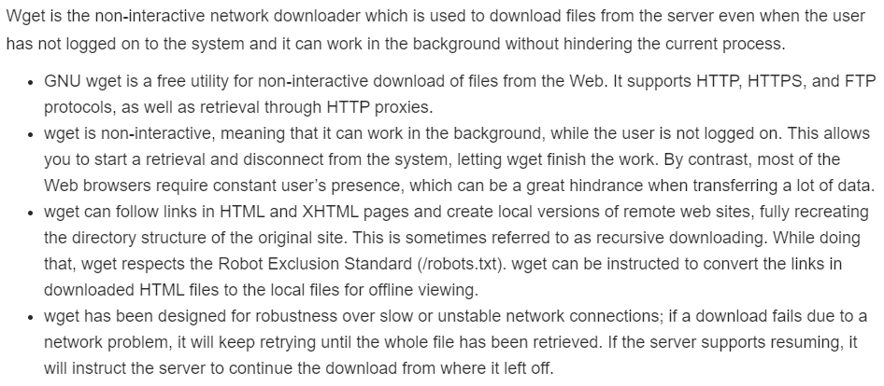

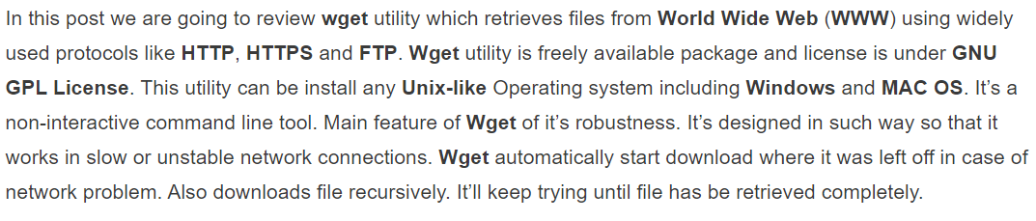

**Installation:**

* **yum -y install wget**

**Examples:**

To simply download a webpage

* **wget** [**http://example.com/sample.php**](http://example.com/sample.php)

to download the file in background

* **wget -b** [**http://www.example.com/samplepage.php**](http://www.example.com/samplepage.php)

To overwrite the log wile of the wget command

* **wget** [**http://www.example.com/filename.txt -o /path/filename.txt**](http://www.example.com/filename.txt%20-o%20/path/filename.txt)

To resume a partially downloaded file

* **wget -c** [**http://example.com/samplefile.tar.gz**](http://example.com/samplefile.tar.gz)

to download single file

* **wget** [**http://ftp.gnu.org/gnu/wget/wget-1.5.3.tar.gz**](http://ftp.gnu.org/gnu/wget/wget-1.5.3.tar.gz)

download file with different name

* **wget -O wget.zip** [**http://ftp.gnu.org/gnu/wget/wget-1.5.3.tar.gz**](http://ftp.gnu.org/gnu/wget/wget-1.5.3.tar.gz)

download multiple files with http and ftp protocol

* **wget http://ftp.gnu.org/gnu/wget/wget-1.5.3.tar.gz** [**ftp://ftp.gnu.org/gnu/wget/wget-1.10.1.tar.gz.sig**](ftp://ftp.gnu.org/gnu/wget/wget-1.10.1.tar.gz.sig)

to download the file in different directory rather than current directory.

* **wget -P /mnt/iso http://mirrors.mit.edu/centos/7/isos/x86_64/CentOS-7-x86_64-Minimal-1804.iso**

version and help

* **wget –version**
* **wget –help**

**curl command:**

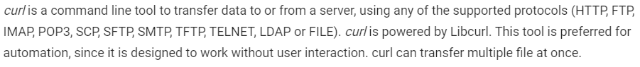

**Examples:**

To display the content of URL in terminal

* **curl** [**https://www.geeksforgeeks.org**](https://www.geeksforgeeks.org)

saves the downloaded file with the name provided in command

* **curl -o hello.zip** [**ftp://speedtest.tele2.net/1MB.zip**](ftp://speedtest.tele2.net/1MB.zip)

to download the file and save it with same name as in URL.

* **curl -O ftp://speedtest.tele2.net/1MB.zip**

to resume the stopped download.

* **curl -C - -O** [**ftp://speedtest.tele2.net/1MB.zip**](ftp://speedtest.tele2.net/1MB.zip)

to download the files with user authenticated.

* **curl -u {username}:{password} [FTP_URL]**
* **curl -u demo:password -O** [**ftp://test.rebex.net/readme.txt**](ftp://test.rebex.net/readme.txt)

to upload a file to FTP server.

* **curl -u {username}:{password} -T {filename} {FTP_Location}**

-x option is to use proxy before accessing the URL.

* **curl -x [proxy_name]:[port] [URL...]**
* **curl -u [user]:[password] -x [proxy_name]:[port] [URL...]**

to download multiple files

* **curl -O http://yoursite.com/info.html -O** [**http://mysite.com/about.html**](http://mysite.com/about.html)

-k option allows insecure sites without certificates.